# Login page:

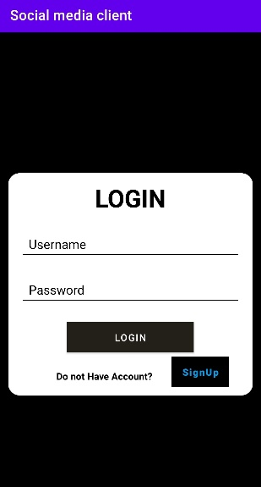

At this activity user can login using his/her credentials… If they do not have their account then they can create new account by clicking on signup button.

# Sign up activity

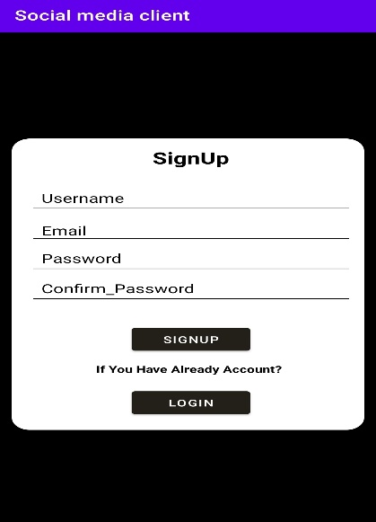

User can create new account just by entering their username, email and password. After writing all the data in the fields users can successfully logged in our app.

# Users Activity

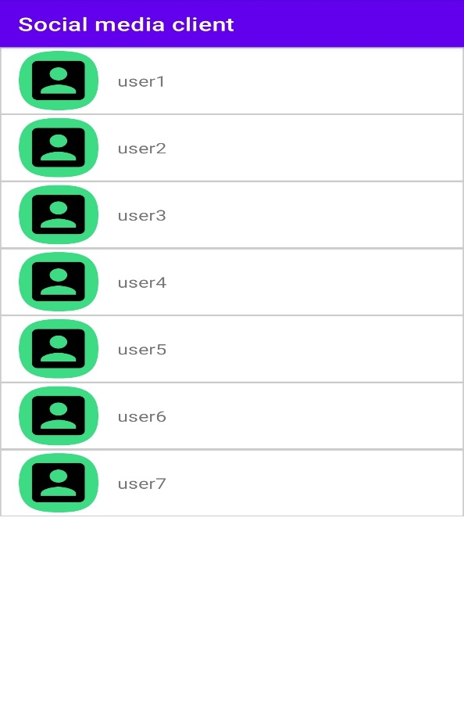

After validating user’s username and password if match successfully a new activity displayed to the user where they can see list of the entire user that have registered their account in our application.

# Logged in users posts

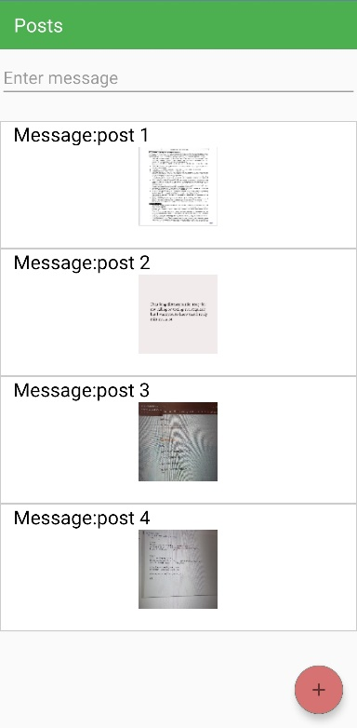

If user clicks on their own name then a new activity will open where all the posts will displayed. If user wants to add new post then he/she needs to click on + sign at bottom right corner. And this + sign is only displayed to current logged user.

# Data entry dialog

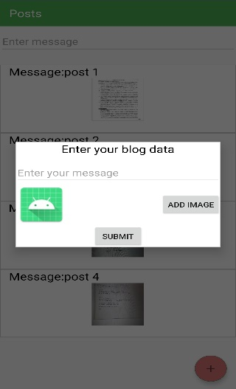

A new dialog box will open when user presses + sign button where he/she needs to enter their blog data i,e, message and image for his post.

# Choice dialog

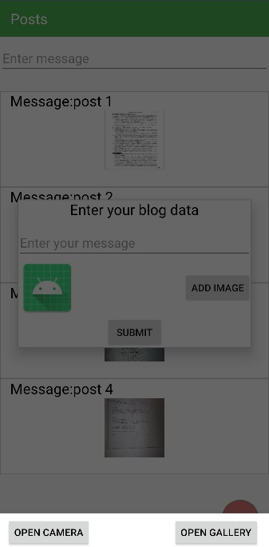

If user wants to attach photo to their message and needs to click on ADD IMAGE button. After clicking this button a new dialog box opens where user has choice whether he select image from gallery or can capture new image using mobile’s camera.

# Group action

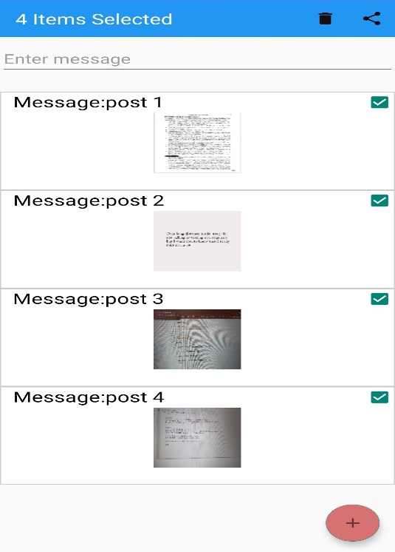

If user wants to perform action on group of posts then he/she needs to long click on any post then checkboxes will appear where they can select posts on which he will perform operation.

They can delete many selected posts at once.

# Search activity

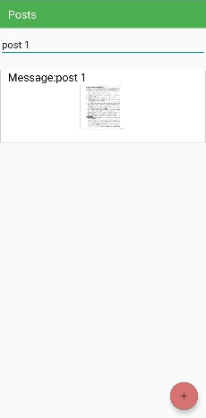

At the top of list of posts they is an edit text field where user can write piece of message and all the matching posts will displayed to the user.

# Detail Activity

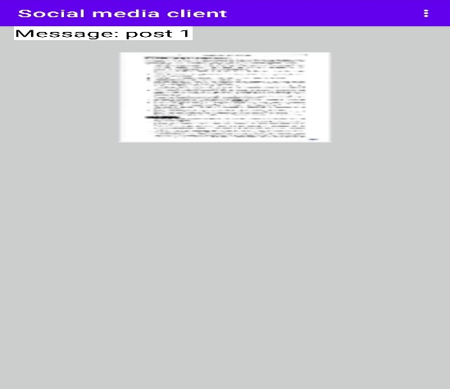

If user clicks on any post then a detail activity will open where they can view detail of the post.

Image and message will display to the user in this activity.

# Other options

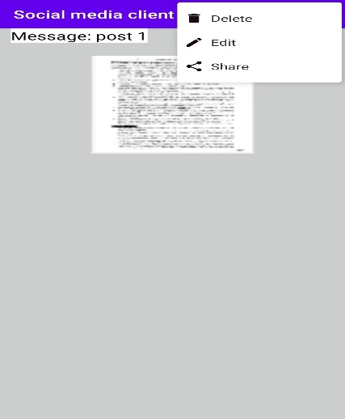

At the top right corner, there are three dots. If user click on them, a menu will appear. He/she can edit, delete and share post from this menu as shown in screenshot.

# Other users posts

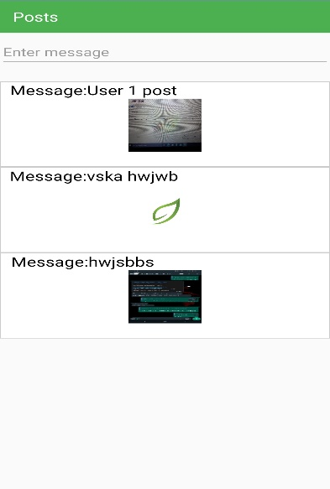

If logged in user wants to view posts of other users then he can click on that user’s name and open all his posts. In this case, there is not + sign for adding new post because logged in user can only view posts of other user.

# Menu for other users

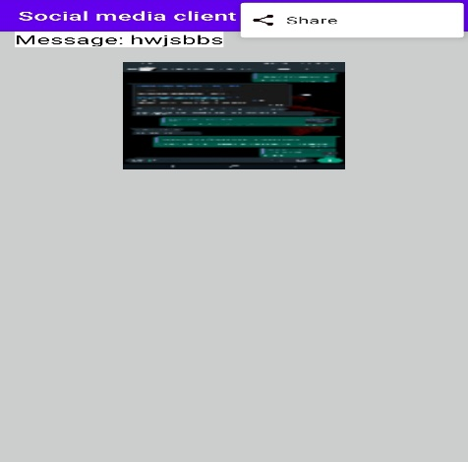

If logged in user open details of other user post then he can only perform one action on that post that is share as shown in screenshot.